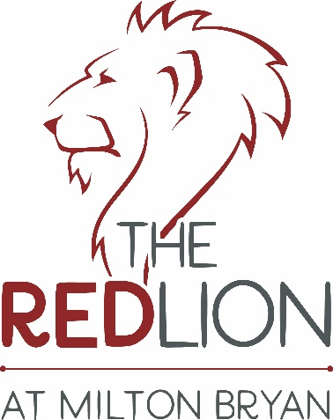
BURGER THURSDAYS
All Burgers £10

Choose from hand-pressed Beef, Chicken Breast, Tim’s 12hr Home Smoked Beef Brisket or the Aromatic Garden Burger (V)

All served in gourmet brioche buns with home-made ketchup, sweet pickle mayo, curly lettuce, red onion & gherkins.
Choose either hand cut chips or skinny fries. Top your burger with cheese, bacon, blue cheese or caramelised onions £1 each

